1. “**RabbitMQ Management Web Interface**” can be used for monitoring and managing the services.
2. It runs by default on 15672 and default username and password are **guest.**
3. After logging in, you will see the Overview which contains general status info about the RabbitMQ service.  
   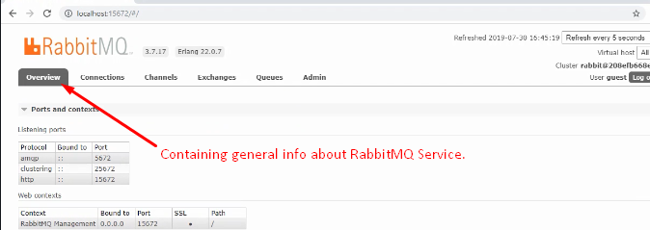
4. 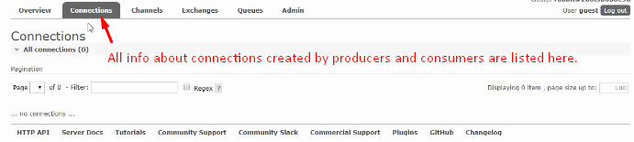
5. **Channels**: These are the virtual connections created by client applications. 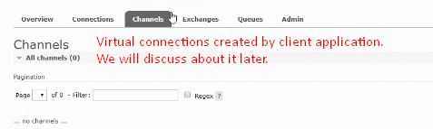
6. **Exchange:** These are message routing elements of RabbitMQ.  
   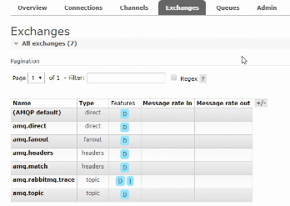
7. **Queue:** Queue is that actually list and hold available messages.  
   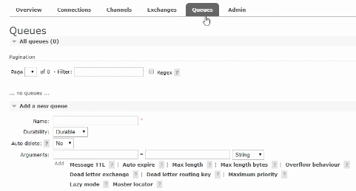
8. **Admin:** Here you can manage users, virtual hosts, feature flex, policies, limits and clusters. 